Future Internet
The Japanese National Institute of Information and Communications Technology (NICT) presented its vision for the New-generation Networks – NWGN in 2008, which aimed to draw up research objectives and technological requirements to facilitate the implement of future knowledge society. The ITU, the institute of the UN specialized for ICT has made its recommendations in the ITU-TY series for the foundation of the standardization of the future network. The recommendations of the ITU-T Y.3000 (especially the 3011, 3021, 3031) identify objectives which do not get enough attention during the planning of the present networks to realize the Future Internet.
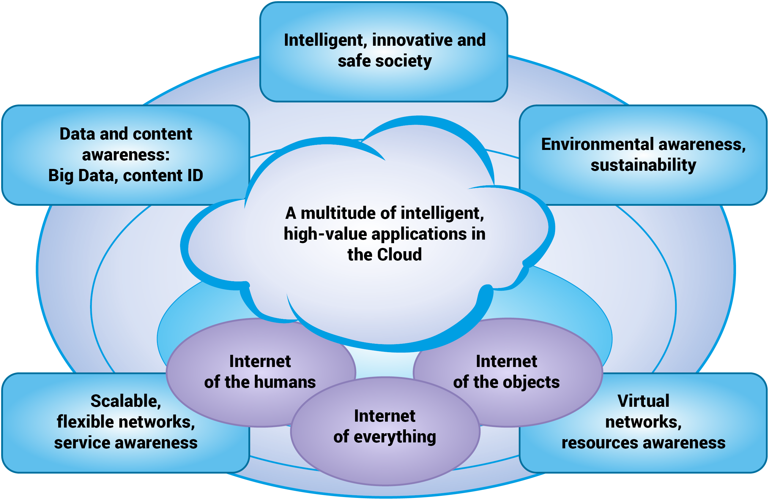
The European Union pays a special attention to the new generation internet research to which Hungary also joins with an active participation. In 2011, in Hungary the Future Internet National Technological Platform was established and in 2013 for its initiation the Future Internet National Research Program was created organized by the Future Internet National Research-Coordinational Centre. An extensive interest is shown by the fact that 34 institutions joined the programme and 132 research topics were registered by the beginning of 2014. The 2014 FIRCC report shows the results of 83 research from the almost complete collection of the national internet research where the „3D internet and the Cognitive Infocommunication, and „The future internet social applications” topics have a prominent role as the 21st century is an age when the human and the ICT are interwoven. This fusion opens a new age in the digital and network life, creates new disruptive technologies, inspires the creation of new scientific areas. The Cognitive Informatics, or ConInfoCom is a new scientific area which publishes research results spanning through a large scale of several scientific areas. In their focus is the investigation of the cognitive processes created by the close interaction of the human mind and the ICT devices.

