General Information:

Name of Course: LANDSCAPE AND GARDEN DESIGN 1.
Course Code: PMRTENE040A
Semester: 8th
Number of Credits: 2
Allotment of Hours per Week: 1 Lectures and 1 Practical Lessons /Week
Evaluation: Signature (with grade)
Prerequisites:

Responsible lecturer: János GYERGYÁK dr., assistant professor
Office: 7624 Magyarország, Pécs, Boszorkány u. 2. B-332
E-mail: gyergyak.janos@mik.pte.hu
Office telephone: +36 72 503650/23840

Instructors: János GYERGYÁK dr., assistant professor
Office: 7624 Magyarország, Pécs, Boszorkány u. 2. B-332
E-mail: gyergyak.janos@mik.pte.hu
Office telephone: +36 72 503650/23840
Péter PAÁRI, doctorate student
Office: 7624 Magyarország, Pécs, Boszorkány u. 2. A-018
E-mail: paari.peter87@gmail.com
Office telephone: +36 72 503650/23840

General Subject Description
The objective of this subject is to offer the basic knowledge and aspects of the design of the green environment including its architectural points. The purpose is to teach students the basics of garden and landscape environmental design and give them the means to create a new approach in design, including the specialized knowledge and that relates to architectural work. The elements of landscape and garden design, their inspection and presentation possibilities and design aspects are the kex topic, meanwhile in each semester the theoretical knowledge is used through a team work design process.

Learning Outcomes
The course will focus on:
- observing the natural environment around the buildings
- analyzing examples of landscape and garden design
- planning methods in small and large scaled designs
- space and form developing
- sustainability in environmental design

Subject content
The course can be divided into two parts; the first parts provides the basic knowledge about the topic, meanwhile the second part is about using the understanding the knowledge by step to step:

- Theories on the field of landscape and garden design
  - Theory of “Landscape and garden design”
  - Theories on the field of “Landscape and garden design concepts of university campuses”
1.3 Case study in related topic: “Landscape and garden design concepts of university campuses”
Presented by groups (max. 3 students/group)

- Design by using the theories of landscape and garden design, based on the „Landscape of the new North Campus at University of Pécs” project
2.1 “Observation of the existing elements (analysis)”
2.2 “Design proposal: Landscape of the new North Campus at University of Pécs”
Presented by groups (max. 3 students/group)

The detailed elements of the contents of the course are listed here:

Theories on the field of landscape and garden design:
  - Theory of “Landscape and garden design”
Students prepare notes and sketches about the elementary theories of the topic.

  - Theories on the field of “Landscape and garden design concepts of University campuses”
Students prepare notes and sketches about the elementary theories of the topic.

1.3. Case study in related topic: “Landscape and garden design concepts of University campuses”
Students in groups (max 3 students in each group) present two university campuses from all over the World in 10 minutes, focusing on the following aspects at least:
urban context ( placement in the urban fabric) - spaces (indoor and outdoor facilities) – paths (connections/connectivity) – edges (borders) – sustainability (any type of meaning)

Design by using the theories of landscape and garden design, based on the „Landscape of the new North Campus at University of Pécs” project

2.1 “Observation of the existing elements (analysis)”
Controlled observation process by using the theory of “Mental map” and focusing on the common program forming for rehumanizing the open public spaces of the new North Campus at University of Pécs.

2.2 “Design proposal: Landscape of the new North Campus at University of Pécs”
_Analysis of the building site
_Inspiration(s) (analysis of case studies)
_Concept of a Site plan 1:2000-1000 (based on the “6 design elements”)
_Site plan 1:500 (in three parts)
_Details 1:50 - 1:10 (detail of the site plan, used built elements, etc.)
_Street furnitures (collection of used street furnitures)
_Used materials and structures (images and text)
_Visualizations (hand or computer drawings)

See the template materials in the ANNEX 01 and ANNEX 02
Format: two boards (two times two printed posters with both sides=4 posters) based on the template 45/100cm provided on the NEPTUN, submission on the last class on the week 15th).

Through the designing process students have to take consider the following terms
(“6 design elements”):
1_Spaces
the result of this division and thus the primary medium of design. Spaces provide for different human uses and enjoyment of the landscape
2_Paths
are considered to be principal structural components of designed landscapes because they play a crucial role in mediating or facilitating the experience and use of landscapes
3_Edges
are explored as distinct physical components of landscape and also as spatial concepts in design. Edges are interlocking forms or places of transition that enclose and separate different spaces.
4_Foci
collective term used to describe focal forms and places in the landscape. The definition here includes landmarks but is not limited to referring to these. Foci describes both forms and places in the landscape that attract people or are visually dominant and distinctive – differentiated from their context.
5_Tresholds
are spatial components of the landscape which provide for integrated, subtle and complex transitions through the landscape. Thresholds are relatively small spaces which ‘sit’ between larger spaces or between buildings and landscape
6_Details
considers surfaces, textures, light, ornament, furniture and colour at a small scale

Examination and evaluation system
In all cases. Annex 5 of the Statutes of the University of Pécs, the Code of Studies and Examinations (CSE) of the University of Pécs shall prevail. https://english.mik.pte.hu/codes-and-regulations

Attending is required all classes, and will impact the grade (max. 10%). Unexcused absences will adversely affect the grade, and in case of absence from more than 15% of the total number of lesson (it is max. 2 lessons) will be grounds for failing the class. To be in class at the beginning time and stay until the scheduled end of the lesson is required, tardiness of more than 20 minutes will be counted as an absence. In the case of an illness or family emergency, the student must present a valid excuse, such as a doctor's note.

Grading will follow the course structure with the following weight:
- “Case study” - 20%
- “Written examination” – 20%
- „Observation: Mental map and program mapping” - 10%
- “Design proposal: Landscape of the new North Campus at University of Pécs”– Poster presentation - 40%
The remaining 10% will be assessed according to participation, progress, effort and attitude. Please note that attendance will adversely affect one's grade, both in direct grade reduction and in missing work in the development of a project.

Important notice:
The course is fullfiled only when all of the grading elements are achieved by at least 50% performance.

The “Written examination” can be reteken only one time on the week of 15th.

Late project submission take 20% deduction per week and the highest possible grade of the „Design proposal” project after Study Period is ‘2’!

The final grade will be based on the following guidelines:

(Grade 5) Outstanding work. Execution of work is thoroughly complete and demonstrates a superior level of achievement overall with a clear attention to detail in the production of drawings, models and other forms of representation. The student is able to synthesize the course material with new concepts and ideas in a thoughtful manner, and is able to communicate and articulate those ideas in an exemplary fashion in.
(Grade 4) High quality work. Student work demonstrates a high level of craft, consistency, and thoroughness throughout drawing and modelling work. The student demonstrates a level of thoughtfulness in addressing concepts and ideas, and participates in group discussions. Work may demonstrate excellence but less consistently than an ‘5’ student.
(Grade 3) Satisfactory work. Student work addresses all of the project and assignment objectives with few minor or major problems. Graphics and models are complete and satisfactory, exhibiting minor problems in craft and detail.
(Grade 2) Less than satisfactory work. Graphic and modelling work is substandard, incomplete in significant ways, and lacks craft and attention to detail.
(Grade 1) Unsatisfactory work. Work exhibits several major and minor problems with basic conceptual premise, lacking both intention and resolution. Physical representation in drawing and models is severely lacking, and is weak in clarity, craft and completeness.

Grading Scale:
Numeric Grade: | 5 | 4 | 3 | 2 | 1
 | A, excellent | B, good | C, avarage | D, satisfactory | F, Fail
Evaluation in points: | 88%-100% | 77%-87% | 66%-76% | 55%-65% | 0-54%

Readings and Reference Materials
Required:
Lectures by the Instructor, which can be found on NEPTUN MEET STREET

More:
1. Chris Young (2009). Garden design, DK Publishing ISBN 978-0756642747 (under acquisition)
2. Aurora Fernández Per, Javier Arpa (2008). The public chance - New urban Landscapes, A+T ISBN 978-84-612-4488-1
3.Emma Reuss (2014). Gardens in Detail: 100 Contemporary Designs , The Monacelli Press ISBN 978-0756642747 (under acquisition)
4. Sarah Gaventa (2006). New Public Spaces, ISBN 978-1845331344
5. Peter Zöch (2008). European Landscape Architecture – Squares, parks and promenades : recent projects, TERC Budapest ISBN: 9639535787
6. Philip Jodidio (2012). Landscape Architecture Now, Taschen ISBN13: 9783836536769

Other study/task materials can be found on NEPTUN MEET STREET

Methodology
The course is based on through collaboration, participation and discussions trough lessons. This is an interaction between Students and Faculty; used the teaching methods like ‘Problem-based learning’ and ‘learning-by-doing’. The communication and work should be reflect a respect for fellow students and their desire to work with regard to noise levels, noxious fumes, etc – from each site of participants. (You will need: sketch paperroll, Rulerscale, sketchbook, pencils, pens, rulers, carton paper for modelling, notebook, internet.)

Students with Special Needs
Students with a disability and needs to request special accommodations, please, notify the Deans Office. Proper documentation of disability will be required. All attempts to provide an equal learning environment for all will be made.

Detailed requirements and schedule of the Course

Week 01 | Monday 9:30-11:00
1st section | Lecture | Practice
Methods | Introduction | -
4th of February | Introduction of the course (sylabus and schedule) | -

Week 02 | Monday 9:30-11:00
1st section | Lecture | Practice
Methods | Theory of the „Landscape and garden design” | -
11th of February | Principles of Landscape and garden design 1. | -

Week 03 | Monday 9:30-11:00
1st section | Lecture | Practice
Methods | Theory of the „Landscape and garden design” | -
18th of February | Principles of Landscape and garden design 2. | -

Week 04 | Monday 9:30-11:00
1st section | Lecture | Practice
Methods | Theory of the „Landscape and garden design” | -
25th of February | Principles of Landscape and garden design 3. | -

Week 05 | Monday 9:30-11:00
1st section | Lecture | Practice
Methods | Theory of the design topic | -
4th of March | Landscape and garden design concepts of university campuses”  Lecturer: Péter PAÁRI, doctorate student | -

Week 06 | Monday 9:30-11:00
1st section | Lecture | Practice
Methods | Theory of the design topic | -
11th of March | Case study in related topic: “Landscape and garden design concepts of university campuses” | -

Week 07 | Monday 9:30-11:00
1st section | Lecture | Practice
Methods | Theory of the design topic | -
18th of March | Case study in related topic: “Landscape and garden design concepts of university campuses” | -

Week 08 | Monday 9:30-11:00
2nd section | Lecture | Practice
Methods | - | Group work
25th of March | „Written examination” 30min. | „Observation:  Mental map”

Week 09 | Monday 9:30-11:00
2nd section | Lecture | Practice
Methods | - | Group work
1st of April | - | „Observation:  program mapping”

Week 10 | Monday 9:30-11:00
2nd section | SPRING HOLIDAY
Methods
8th of April

Week 11 | Monday 9:30-11:00
2nd section | Lecture | Practice
Methods | - | Consultation
15th of April | - | Design task in group scale  „Landscape of the new North Campus at University of Pécs”

Week 12 | Monday 9:30-11:00
2nd section | Lecture | Practice
Methods | - | Consultation
22th of April | - | Design task in group scale  „Landscape of the new North Campus at University of Pécs”

Week 13 | Monday 9:30-11:00
2nd section | Lecture | Practice
Methods | - | Consultation
29th of April | - | Design task in group scale  „Landscape of the new North Campus at University of Pécs”

Week 14 | Monday 9:30-11:00
2nd section | Lecture | Practice
Methods | - | Consultation
6th of May | Retaking of the „Written examination” 30min. | Design task in group scale  „Landscape of the new North Campus at University of Pécs”

Week 15 | Monday 9:30-11:00
2nd section | Presentation of the „2nd section - „Landscape of the new North Campus at University of Pécs”
Methods
13th of May

We reserve the right to make changes to the details of this course syllabus (date / location / clarifications), which will be communicated to the students. In case of questions and problems that arise during the semester contact the responsible lecturer or the study program coordinator.

Donat RETFALVI dr.
responsible lecturer

Pécs, 04.02.2019

ANNEX 01

Inspiration for site plan:

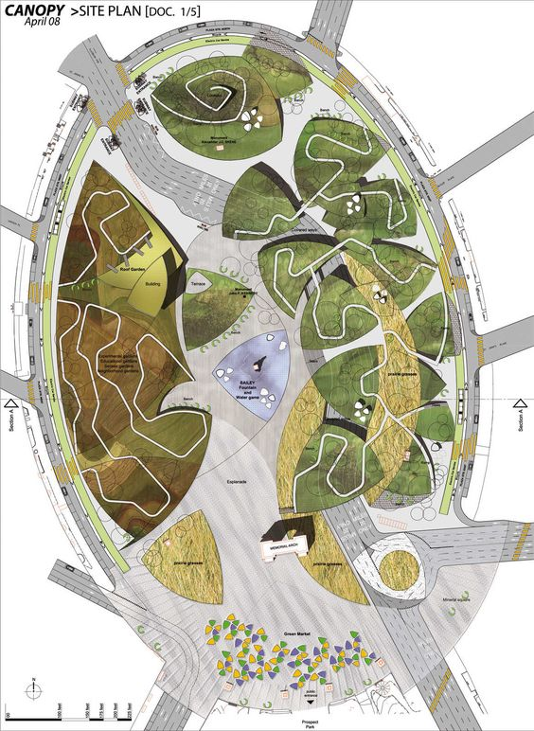

ANNEX 02

Inspiration for the content of
the poster:
